Environment: UAT
Bank : DBS
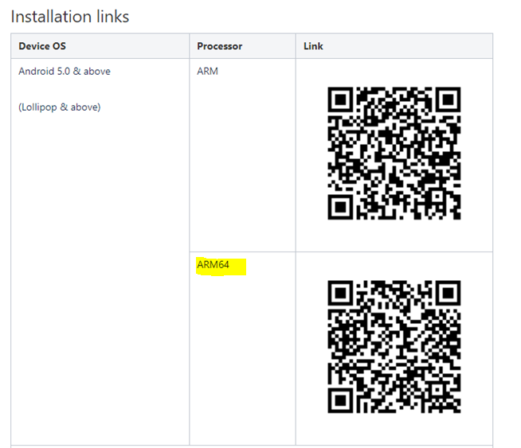

Pls make the following in Settings
Environment: UAT
Bank : DBS

